Name(s)______________________________________

Random Sampling Lab Activity

Chapter 5: Populations
Scientists cannot possibly count every organism in a population. One way to estimate the size of a population is to collect data by taking random samples. In this activity, you will look at how data obtained from random sampling compare with data obtained by an actual count.
Procedure:
- Cut the bottom grid out at the bottom of the page.

- Number 10 of the slips from 1 to 10 and put them in a small container.

- Label the remaining 10 slips from A through J and put them in a second container.
The grid shown below represents a meadow measuring 10 m on each side. Each grid segment is 1 m x 1 m. Each black circle represents one sunflower plant.
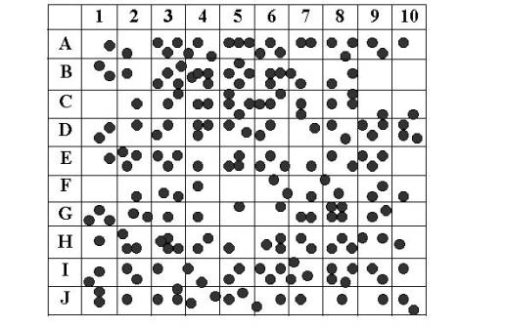

- Randomly remove one slip from each container. Write down the number-letter combination and find the grid segment that matches the combination. Count the number of sunflower plants in that grid segment. Record this number on the data table. Return each slip to its appropriate container.

- Repeat step 5 until you have data for 10 different grid segments (and the table is filled out). These 10 grid segments represent a sample. Gathering data from a randomly selected sample of a larger area is called sampling.

- Find the total number of sunflower plants for the 10 segment sample. This is an estimation based on a formula. Add all the grid segment sunflowers together and divide by ten to get an AVERAGE number of sunflower plants per grid segment. Record this number in the table. Multiple the average number of sunflower plants by 100 (this is the total number of grid segments) to find the total number of plants in the meadow based on your sample. Record this number in your data table.

- Now count all the sunflower plants actually shown in the meadow. Record this number in the data table. Divide this figure by 100 to calculate the average number of sunflower plants per each grid.

Random Sampling Data |  |  | Actual Data  Total number of Sunflowers ______  (count by hand)  Average number of Sunflowers  (divide total by 100) Per grid _____  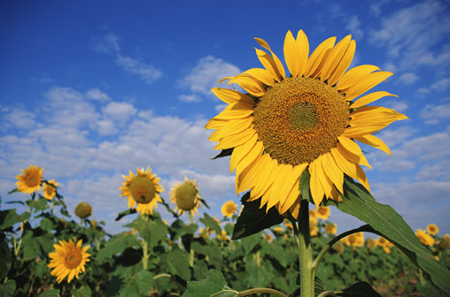  http://rushthecourt.net/mag/wpcontent/uploads/2010/03/sunflower-showdown.jpg
Grid Segment  (number-letter) | Number of  Sunflowers
Total Number of
Sunflowers
Average per grid
(divide total by 10)
Total number of plants in meadow (multiply average by 100)

Analysis:
- Compare the total number you got for sunflowers from the SAMPLING to the ACTUAL count. How close are they?

- Why was the paper-slip method used to select the grid segments?

- Why do biologists use Sampling? Why can’t they just go into the forest and count all the sunflower plants?

- Population Sampling is usually more effective when the population has an even dispersion pattern. Clumped dispersion patterns are the least effective. Explain why this would be the case.

- Describe how you would use Sampling to determine the population of dandelions in your yard.

- In a forest that measures 5 miles by 5 miles, a sample was taken to count the number of silver maple trees in the forest. The number of trees counted in the grid is shown below. The grids where the survey was taken were chosen randomly. Determine how many silver maple trees are in this forest using the random sampling technique. Show your work!
 | 7
 |  |  |  | 3
 |  |  | 5
11 |  | 9

